Terra Energy Corporation
2012
Alexandra Grosset
Grande Prairie Regional College
11/14/2012
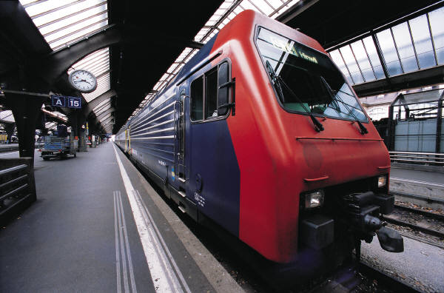

TERRA ENERGY CORPORATION

T
erra Energy Corporation is a development-stage company that was incorporated on May 1, 1999. The Corporation and its subsidiary (collectively referred to as the “Company”) designs, develops, configures, and offers for sale power systems that provide reliable, high-quality, environmentally friendly power. The Company has segmented the potential markets for its products into three broad categories: high-energy; high-power uninterruptible power system; and high-power distributed generation and utility power-grid energy storage system. We have available for sale several high-energy products that deliver a low level of power over a long period of time (typically measured in hours). These products are tailored to the telecommunications, cable systems, computer networks, and Internet markets.
We are developing a new high-energy product for potential applications in the renewable energy market for both photovoltaic and wind turbine uses. As part of exploring these markets, we have committed to invest $2 million in Clear Sun Energies, and we have purchased the inverter electronics technology of Technology Pacific.
We have taken significant action over the last eighteen months to reduce our expenditures for product development, infrastructure, and production readiness. Our headcount, development spending, and capital expenditures have been significantly reduced. We have continued the preliminary design and development of potential products for markets under consideration and with specific approval by the Company’s board of directors.

R&D Manufacturing
Historically, our manufacturing has consisted of the welding and assembly of our products. We have previously contracted out the manufacture of our high-energy flywheel components, using our design drawings and processes to facilitate more rapid growth by taking advantage of third-party installed manufacturing capacity. For a limited number of nonproprietary components, we generate performance specifications and obtain either standard or custom components.
Our facility is underutilized as a result of reductions in development work and customer orders for production. We are maintaining a limited manufacturing staff, many of whom are skilled in quality control techniques. We expect to continue to utilize contract manufacturing and outside suppliers in the future based on our estimate of product demand from potential customers. The suppliers of the mechanical flywheel and the control electronics for our high-power UPS product are both single-source suppliers, and the loss of interruption of supply from either of these suppliers would adversely affect our ability to market and deliver our high-power UPS product and, thus, our financial results. To manage cost and supplier risk, we may elect to manufacture composite rims (the most expensive portion of flywheel units) in our facility if we determine that it is in our best interest to do so. We have personnel skilled in management, design, and the manufacturing of composites that will manage our manufacturing processes.

Sales and Marketing
We are marketing our products directly to customers and attempting to build market interest through power-quality manufacturers’ representatives and through lead generation via advertising, trade press articles, participation in industry conferences, technical presentations to potential customers, and limited direct mail to specific power-quality customers. We believe that this strategy could evolve into alliances and channel partnerships, involving relationships with power-quality manufacturers’ representatives, OEMs, architects, engineers, system integrators, electrical contractors, and power-quality personnel in electric utilities.
With respect to our existing high-energy back-up power products, our marketing strategy has been to identify key prospects and to work with those companies to formulate our product plan, pricing, initial installation, and service strategies. We will continue to perform market analysis to identify opportunities for installations that fit the unique characteristics of those products and to emphasize the value proposition of our high-energy products. Potential customers for these products include businesses with heightened needs for 100% reliability, such as hospitals, data centers, call centers, and other critical-use facilities. We believe that our high-energy products will also be attractive to customers with power sources that are very expensive to replace or maintain due to their location or other factors, or to customers with power sources located where high or low prevailing temperatures or dramatic changes in temperatures exist.

